# [Home](http://172.27.163.9:8080/KPIF/KPIF/server/general/projects_responsive/KPIF%20Knowledge%20Base/Home.htm) > Universal Processes > Document Note in TapMem

# Document Note in TapMem

## Overview

## Purpose

The purpose of this document is to provide instructions on how to document a note in Tapestry Membership (TapMem).

## Process Owner(s)/Primary User(s) of DLP

* Account Administrative Representative (AAR)
* Analyst(s)/Consultant(s)
* Accenture Business Operations

## Summary

A user may need to document notes within TapMem to describe member’s ongoing situation.

## Related Policies

## Procedure

|  |  |  |
| --- | --- | --- |
| Step 1 | Step 2 | Step 3 |
| Document Note in TapMem | Adding a Person Level Note in TapMem | Adding a Coverage Level Note in TapMem |
| Step 4  Adding Alert Notes in TapMem |  |  |

## Document Note in TapMem

1. Launch TapMem and login using your UserID (NUID) and Windows password.
2. Once logged into TapMem, from the menu bar tool bar select Member Inquiry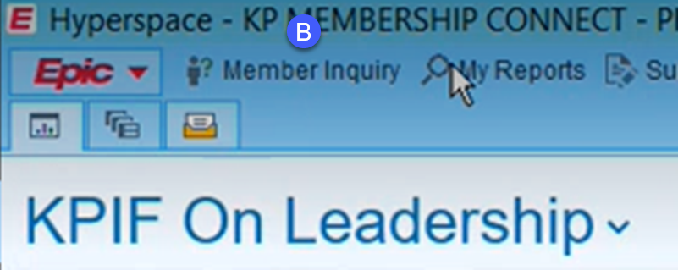



* 1. The **Patient Lookup** pop-up dialog box will appear. In the **Name/MRN** field, enter the member’s partial or full name.
  2. Click **Find Patient**.

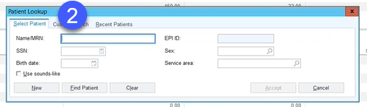

* 1. Select the appropriate member from the **Patient Select** pop-up screen.

## Adding a Person Level Note in TapMem

Patient/Person level notes are needed for updates made at the Patient Level, usually demographic updates such as Name, DOB etc.

1. Once the member is found, on the Member Snapshot page navigate to the **Notes** tab.

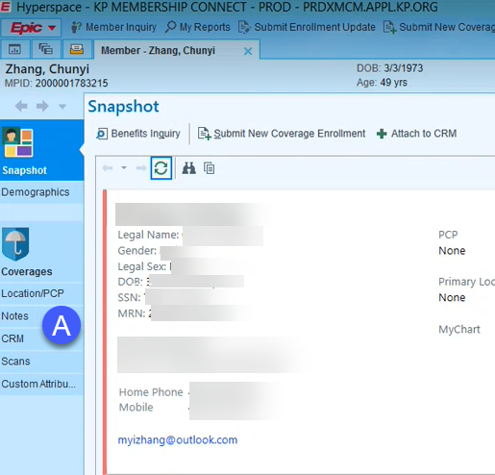

1. Select **New Note**
2. Select appropriate Note Type for the type of update processed (manual update, refund, adjustment, or bankruptcy).
3. Select Smartphrase as appropriate for the update made to the person. Smartphrases starts with a period. Refer to the **Smart Phrase and Note Text References** DLP.

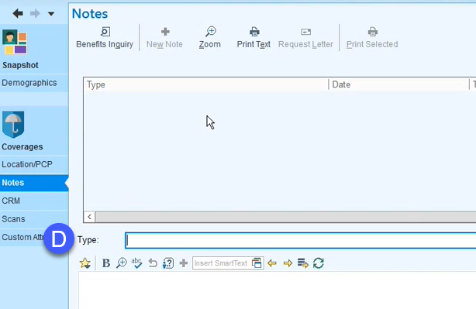

|  |  |
| --- | --- |
| **Note** | |
|  | If you are adding free form text, type directly in the note. Copying and pasting the text of the note from a Word Document will cause errors. |

1. Populate the rest of the template and note body
2. Click “Accept Note”

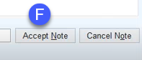

## Adding a Coverage Level Note in TapMem

Coverage level notes are needed for updates impacting the member’s coverage, such as create new coverage, terminate coverage, effective date changes

1. From the coverage record that was updated click on the Notes tab

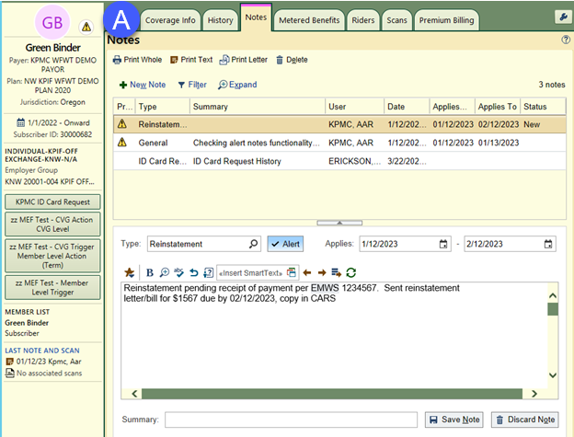

1. Click New Note

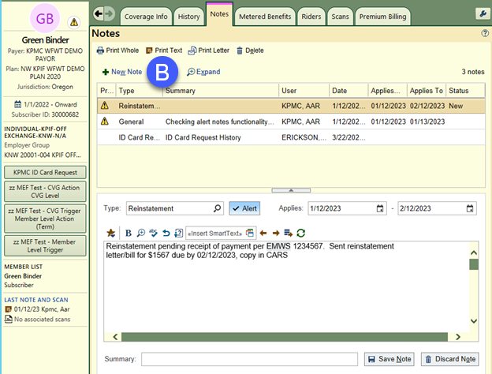

1. Select the Note Type and Smartphrase as appropriate for the type of update to the coverage. Refer to the **Smart Phrase and Note Text References** DLP.

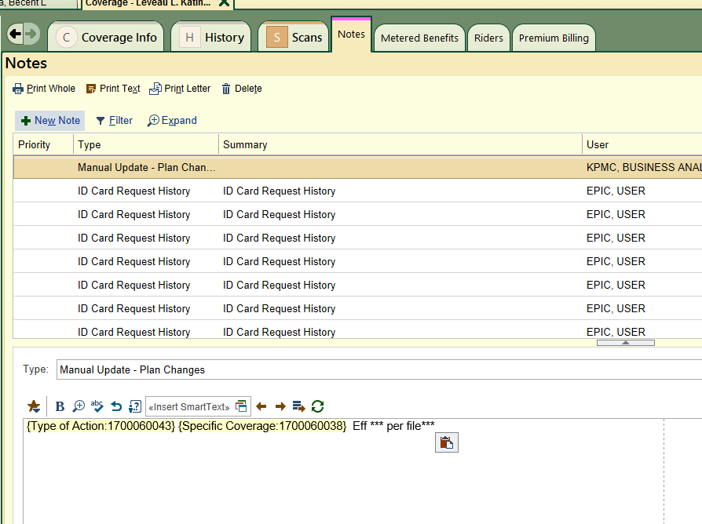

1. Click “Accept Note”
2. **Setting Alerts on Notes in TapMem**

You can set an alert on a note in TapMem so that the note appears at the top of the **Notes** list for a specific period of time with an indicator to mark its importance.

**Example use cases:** Time sensitive reinstatement approvals and authorizations to release information.

1. Click the **Alert** check box next to the **Type** drop down box
2. Enter the dates of when the note alert should be applied.
3. Once the note has been created and alert has been set, click **Save Note**.

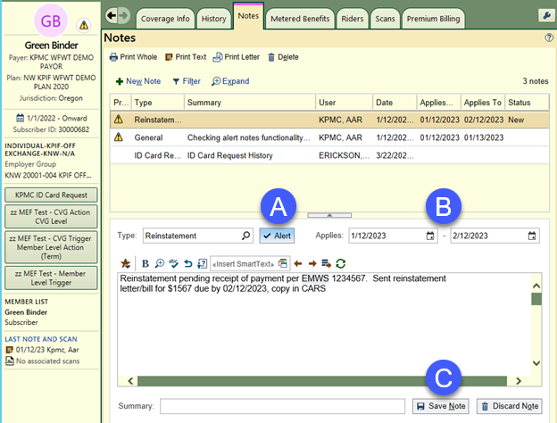

An alert note indicator will appear next to the note at the top of the list and will also appear in the navigation pane next to the member’s profile icon for the duration of the specified time frame.